St Mary’s Literacy framework: Reception

This table provides an overview of the texts that we plan for children to encounter over the course of their Reception year. We sometimes make adaptations to this list in order to best meet the needs and interests of the children. This table also highlights possible learning experience that children will have linked to these texts. These activities will have links across the curriculum but will particularly support Communication and Language Development, Reading and Writing. An overview of the key learning focus’ for these areas can be found in our Reception Progression Map.
Autumn One
Key Focus Text | Suggested Provision for extending vocabulary; orally retelling texts and creating their own narratives | Suggested Writing Provision  At this stage activities will also include opportunities for mark making and drawing
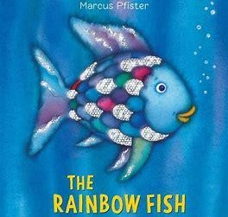 | - Creating their own Rainbow fish/developing descriptive language  - Small group discussions about their own experience of sharing  - Rainbow fish puppets to encourage orally retelling the story  - A range of fish and shells in water trays for children to retell the story and possibly create their own story.  - Cards to sequence the story. | - Creating a thank you card for the rainbow fish  - Mark making in the sand – this could include messages for the Rainbow Fish  - Rainbow mark making with paints (this can include paining letters learnt in Phonics and/or their names.)
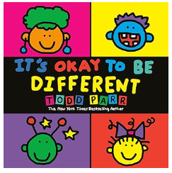 | - Bringing in photographs of their families that they can talk about in small groups and pair  - Creating self-portraits of themselves | - Drawing pictures of their families.  - Labelling their pictures with the names of different family members
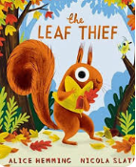 | - Collecting Autumn Leaves in Oakhill Park and around. They could be asked to describe these leaves.  - Recording messages for the Leaf Thief  - Creating their own leaf collages  - Thinking for leaves- e.g a boat, a dress or a necklace | - Making signs for the Leaf Thief  - Writing labels for collages that they have made.

Autumn Two
Key Focus Text | Suggested Provision for extending vocabulary; orally retelling texts and creating their own narratives | Suggested Writing Provision  At this stage activities will also include opportunities for mark making and drawing
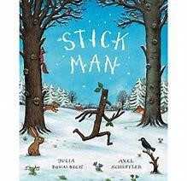 | - Visiting the park and creating their own stickmen  - Creating a class story map and orally retelling the story  - Cards available to sequence the story  - Small world scene set up using leaves and natural materials  - Creating different items with a stick –then showing these to their friends  - Watching animated version of the Stick man as a stimulus | - Mark making with sticks in the mud and sand  (this can include writing letters or your name)  - Materials to create their own pictures from part of the story map  - Using phonic knowledge to label pictures from the story.
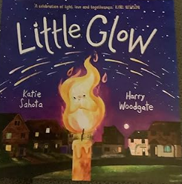 | - Creating firework pictures linked to the celebrations of Diwali and  - Bonfire night.  - Creating Diwa lamps for their own little glow candles  - Bringing pictures of different celebrations they have taken part in at home. | - Making cards for different events. They could write simple messages in cards or just write who they are from.  - Labelling pictures associated with some of the festivals they are learning about.
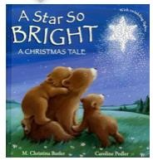 | - Role play area to be set up as a nativity scene  - Crib to be set up in the classroom (Adult led activities will include using these figures to talk about the story  - Puppet theatre to be set up with figures from the Christmas story  - Taking on the role of different animals in the story and thinking about what they would say and where they would want to stand when they are in the stable.  - Creating their own starry night scenes | - Writing Birthday cards for Jesus  - Using glitter and glue to mark make and practise letter formation on dark paper ( this could be linked to making their own starry night sky)  - Children who are ready could create their own story maps of key events in the story.
Spring One
Key Focus Texts | Suggested Provision for extending vocabulary; orally retelling texts and creating their own narratives | Suggested Writing Provision and activities  At this stage activities will also include opportunities for mark making and drawing
Goldilocks and the Three  Bears  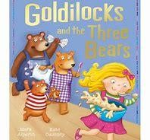 | - Role play area to be set up as three bears house so children can act out the story  - Children to pretend that they are investigating who broke into the three bears house  - Props in the indoor and outdoor areas so that children can retell the story  - Cards for sequencing the story  - Create a crime scene the role play area and make up stories about what could have happened  - Following instructions for making porridge. Describing how the porridge changes | - Signs to warn Goldilocks to keep out  - Tracing and mark making in the porridge oats  - Clipboards to write / draw pictures of Creating their own story maps  - Provision for creating sorry cards.
Whatever Next  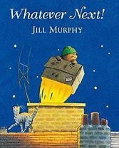 | - Role play area to be set up with items for the story and a picnic set • destination they were flying too.  - Plan the own journey to the  - Read further texts about space  - Pretend to go on a journey to space. Children could create a giant space picture of what they can see in Space  - Story box activity to encourage the children to create their own versions of the story. They could change the character the meet on the way or by | - Making a list of items they want to take on a visit for the moon  - Creating a postcard from the moon  - Resources available in the free writing areas that encourage writing about Space  - Practising writing letters in space (using chalk to write on dark paper
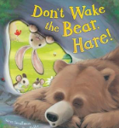 | - Creating their own snow scene pictures  - Small world props set up in fake snow or fake snow for children to explore and describe.  - Creating their own snow paintings.  - Watching books and films about animals that hibernate and having discussions afterwards  - Ice set up in the active world tray for children to observe. | - Painting snow letters (with white paint on dark paper)  - Creating their own zig zag books based on key points in the story.  - Some children could create their own story maps showing what happens in the story

Spring Two
Text | Suggested Provision for extending vocabulary; orally retelling texts and creating their own narratives | Suggested Writing Provision  At this stage activities will also include opportunities for mark making and drawing
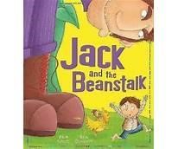 | - Creating models of what would be at the top of their beanstalk and talking about them with friends.  - Small world toys set up so that children can create their own story  - Story box activity in groups. The children will make up their own story in which they changing what they find at the top of the story (this will be modelled by an adult  - Creating dishes in the role play area for the Giant.  - Puppets so that children can retell the story | - Creating labels for their plants  - Thinking about what could be at the top of a beanstalk and creating a class book for the Reception library.
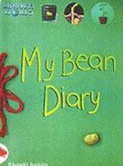 | - Follow instructions to plant their own beanstalks  - Using play dough to create and describe their own bean stalks  - Gardening equipment, pots, small seed sized items and earth will be set up in the outdoor area so that children can pretend to plant new flowers.  - Cards to sequence the growth of a new plant. | - Writing guidance for members of staff to explain how to plant a bean stalk  - Writing guidance on how to look after a bean stalk e.g. “Water your bean every day”  - Mark making with mud
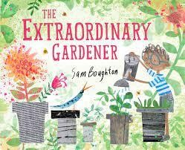 | - Looking for the most extraordinary plants in Oakhill Park  - creating their own garden boxes in small groups  - (with construction toys or paints)  - Painting different flowers such as daffodils –describing  - Using natural items collected from school ground Park to create potions and garden pictures in the outdoor area • Planting different flowers | - Creating a picture of an extraordinary garden. Write simple sentences to label and describe this garden.  - Writing a message / letter to Mr Waller asking him to help them create their own gardens.  •

Summer Two
Text | Suggested Provision for extending vocabulary; orally retelling texts and creating their own narratives | Suggested Writing Provision  At this stage activities will also include opportunities for mark making and drawing
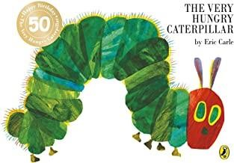 | - Observing caterpillars as they change into butterflies. They could record updates for the school website  - Painting pictures of butterflies and describing what they look like • Props and puppets to be set out for children to retell the story.  - Children to be encouraged to role play their own versions of the story- perhaps changing the food that the caterpillar could eat. | - Writing observations about the class caterpillars. These could then go out the website  - Writing their own versions of the Hungry Caterpillar- this could be carried out as a group or as a class.  - Posters reminding other children to be careful near the caterpillars
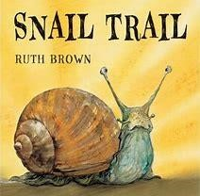 | - Painting a story wall  - Roleplaying the journey that the snail has gone on.  - Describing a different journey that a snail could go on- creating different landscapes for him to travel along.  - Hot seating the snail about how he felt during his journey. | - Creating captions showing how the snail feels at different points in the story. These could be attached to the story wall  - Creating their own snail trail writing by using water in the outdoor area.
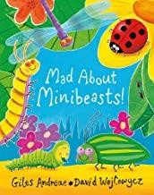 | Making models with play dough  Looking for mini-beasts in the school grounds. Describing what they have seen  Creating their own playdough mini beasts  Playing “Guess which mini beast I am thinking of . One child would give a description of a mini beast and the others have to guess which mini beast they are thinking of. | - Keeping a record of the manifests they have seen around the school (This cold include labelling pictures that they have drawn_  - Creating fact files about mini beasts. These could be to help Year Two with he

Spring Two
Text | Suggested Provision for extending vocabulary; orally retelling texts and creating their own narratives | Suggested Writing Provision  At this stage activities will also include opportunities for mark making and drawing
Mad about Dinosaurs  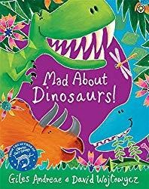 | - Creating pictures of their favourite Dinosaurs.  - Designing their own imaginary dinosaur and deciding what it would be called, what it would look like and what it would eat.  - Create a scene where dinosaur eggs have been found. Creating a news report about their amazing  - Small world dinosaurs to be set up | - Creating a fact file for their own imaginary dinosaur  - Creating signs explaining that they have found dinosaurs.  - Writing messages to tell everyone about the dinosaur eggs that have been found.
The Girl and the Dinosaur
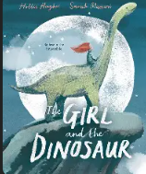
Emma Janes Aeroplane  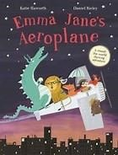 | - Sequencing pictures from the story  - Using props creating their own imaginary aeroplane journey  - Think about places they would want to travel to on an aeroplane  - Role playing conversation between Emma Jane and the animals  - Creating models of places that they would like to visit (could be using old junk or construction toys  - Setting up the role play area as an aeroplane | - Writing a post cards from Emma Jane  - Create a map of journey that they would like to go on  - Writing thank you messages to the animals that rescued the aeroplane

