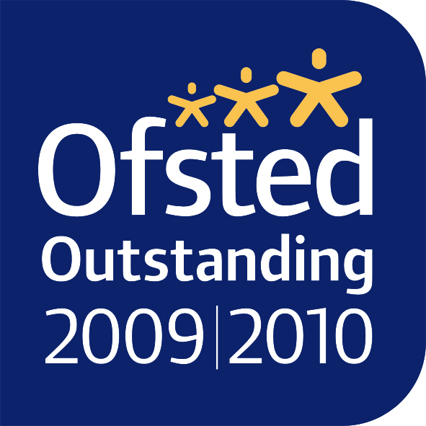  Headteachers:  Mrs M. Adams MA  Mrs M. Constantinou BEd  Littlegrove, East Barnet, Herts EN4 8SR  t: 020 8449 5856  e: office@stmarysen4.barnetmail.net  www.stmarysen4-barnet.co.uk | learning in faith in  St Mary’s  Church of England  Primary School

Reading Policy

VISION
Inspired by Christian values, at St. Mary’s we are EXCITED about our learning, PROUD of our achievements, DETERMINED to be the best we can be and CARING for all of God’s creation.
MISSION
- Through excellent teaching we will deliver an inspirational curriculum
- We will enable every child to make the very best progress
- We will work in partnership with children and families to further promote confidence and self esteem
- We will prepare children to confidently face the challenges of growing up in the 21st Century
- We will provide children with an understanding of local, national and global communities and faiths.
- With St Mary’s Church, Brookside Methodist, and other local churches, we will further develop understanding of gospel values in action through worship and across the curriculum

Rationale
The reading policy at St Mary’s Church of England School forms part of the overall Teaching and Learning Policy. As reading is a complex linguistic skill, which develops gradually in parallel with the spoken and written language of young children, this policy needs to be set in the broader context of developing children’s speaking and listening skills and writing skills. The purpose of this policy statement is to ensure a common shared outlook and approach to teaching and developing children’s reading, to aid consistency, coherence and continuity throughout the school.
Aims

‘So it is with children who learn to read fluently and well: They begin to take flight into whole new worlds as effortlessly as young birds take to the sky’
William James

We want our children to:
- Develop an enthusiasm for reading and an enjoyment of books, which leads to a desire to want to read for both pleasure and for information.
- Develop the skills and competencies necessary to read fluently, understand and respond to a variety of texts (both fiction and non-fiction).
- Develop the skills of reading necessary for information gathering and for the purpose of study.
- Develop reading in all subjects to support their acquisition of knowledge.
- Read widely at school and at home and use the library at school to help do so.
- Leave St. Mary’s with a life-long love for reading.

Principles
All children at St Mary’s Church of England School are seen as readers. Reading should be viewed as an enjoyable, rewarding activity and children should feel they are succeeding from the outset. The following principles lie behind our approach and are underpinned by high quality, evidence-based research, such as recommendations from the Education Endowment Foundation (EEF).

- Creating the desire to read is crucial if children are to develop as readers and the quality of material offered to children is an important factor in creating this.

- Any reading that takes place must involve gaining meaning from print.

- The role of the teacher, teaching assistant and parent/carer is vital in the development of children as readers. Teaching supports children to gain meaning and pleasure from text and by appropriate interventions teach them to use an increasing range of reading strategies, so that they grow in independence.

- Knowledge of authors, illustrators and publishers will encourage children to develop opinions and develop a critical approach to reading.

- Involving children in diverse books that illuminate their experience, enrich their language and learning and make them aware of words beyond their everyday experience is likely to make them life-long readers.

Approach
In our teaching of reading, we carefully consider the two strands of word recognition and language comprehension, as illustrated in Scarborough’s Reading Rope below.
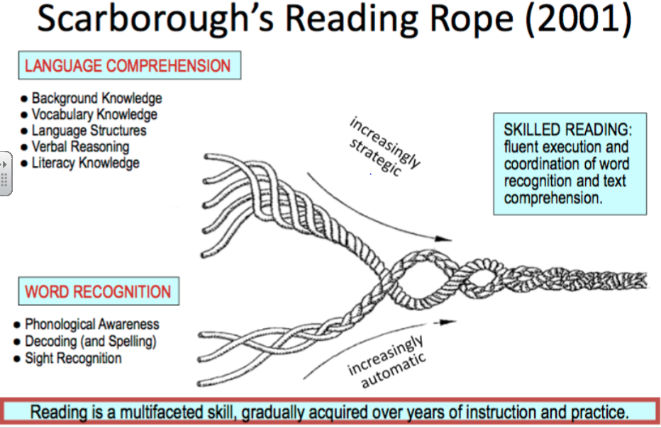

Our English curriculum is based around carefully chosen, high quality fiction and non-fiction texts (please refer to our Curriculum Maps). They represent a wide range of genres and cultures and cover a variety of topics.
We demonstrate to children that reading enables us to acquire knowledge and to build on what we already know. Staff model reading for enjoyment, through discussing what they love to read and why. Across the school, children are encouraged to challenge and discuss their ideas with each other, building on their ability to communicate their thoughts clearly and justify their opinions.
Reading is taught through daily reading opportunities, such as whole-class shared reading, group reading, phonics sessions and reciprocal reading discussions/activities. Skills of decoding, fluency, inference and deduction are taught, which children can apply to any genre of text.
High quality texts are at the heart of our curriculum and are shared reading is part of our daily practice. KS1 and KS2 children visit the school library for an opportunity to browse and choose books to borrow. We celebrate World Book Day every year and children enjoy browsing and buying books at our annual book fair.
Each week during our Church Service with the whole school, a number of children from Year 6 and Year 3 read aloud passages from the Bible and prayers. This involves taking Readings home to practise and allows parents to support them with this. Every day, all children are exposed to reading opportunities in Worship through singing (lyrics are projected onto a screen, read through and their meaning is discussed).
A highlight of the year in KS2 is when we have our annual Shakespeare workshops and theatre visit. The children’s participation in the workshops supports their comprehension and vocabulary development of Shakespearean language before they begin their unit of work. By the time the children leave St. Mary’s, they will have studied 4 Shakespearean texts, participated in 4 workshops led by the Young Shakespeare Company and seen 4 live theatre productions of the plays at the Wyllyotts Theatre in Potters Bar.

Phonics

At St Mary’s we follow ELS (Essential Letters Sounds), which is a systematic synthetic phonics program that has been validated by the DFE. All teaching staff (including teaching assistants and new staff) undertake comprehensive ELS training. This training enables us to maintain fidelity to the program by ensuring that staff have a strong phonic knowledge and understand how to teach the different components of ELS.

ELS focuses on developing phonological awareness, phoneme-grapheme recognition and the strategies of blending to read and segmenting to spell. The ELS phonics program is introduced in the first three weeks of Reception and we then follow the ELS progression chart into Year One and if necessary Year Two and beyond.

In line with the Essential Letters and Sounds program, children in Reception and Year One take part in daily phonics lessons. When delivering these sessions teachers follow the Review, Teach, Practice and Apply structure outlined in the ELS program. During these discrete phonics lessons additional adults are carefully deployed and play an important role in supporting children and encouraging active participation.

Regular assessment is an integral part of our Phonics curriculum. Teachers and teaching assistant are continually assessing children’s phonic knowledge during daily lessons. In addition, we carry out ELS assessments on a half termly basis. Through these assessments we are able to quickly identify gaps children may have in their phonic knowledge and skills. We then address these gaps by implementing the appropriate ELS interventions. The English Learning Leader and SENCO work closely with class teams to ensure that assessments are accurate and that the appropriate interventions take place in a timely manner so that children are able make the best progress possible.

Decodable Reading Books

Children apply their phonic knowledge by reading decodable books that match their phonic knowledge. These books are taken home and children are encouraged to practise reading them at least four times over the course of the week.

Application of Phonics Across the Curriculum

When children are engaging in reading and writing activities across the curriculum, teachers encourage them to use knowledge and skills from discrete phonics sessions. This is promoted through explicit modelling, drawing children’s attention to phonics resources such as friezes and by regularly reminding children about their expectations.

Home Support
Support at home is very important when children are developing early reading skills. For this reason, reading is always a key focus at parents’ evenings and parents/carers are encouraged to attend Early Literacy skills workshops that take place when children are in Reception and Year One. Parents and carers also receive a range of resources to help them understand how they can best support reading in the home.

Reading Books Beyond the Early Stages of Reading
When children are able to read in a fluent manner, they move away from schemes and start reading books that are part of our Accelerated Reader program. This program allows us to keep a record of texts that the children read whilst also enabling us to monitor their understanding of texts.

Fluency
- “Fluent reading supports comprehension because pupils’ cognitive resources are freed from focusing on word recognition and can be redirected towards comprehending text.” Education Endowment Foundation

As children become more confident with decoding text, we support them in developing their fluency, by considering the following aspects:

Automaticity: rapid word reading without conscious decoding (sounds like talking)
Accuracy: often measured as correct words per minute.
Prosody: expressive, phrased reading: the child must be able to put meaning into the text as they read it – reading with the eyes and brain.

One of the key techniques we use to support children with their fluency is echo reading, which involves pupils ‘echoing’ the teacher’s ‘read aloud’, one sentence at a time, trying their best to mimic fluency, expression and intonation. There is discussion around why the teacher used certain expression, volume or intonation. Reference to use of punctuation marks is also made.

Comprehension Skills

Throughout their reading journey, we seek to develop children’s comprehension skills through reciprocal reading. This involves scaffolded discussions that incorporate four main strategies (the ‘Fab Four’) that readers use together to comprehend text:
- Predicting
Predicting goes beyond guessing and involves previewing the text to anticipate what may happen next. Readers can use information from the text along with their prior knowledge to make logical predictions before and during reading. This encourages a purpose for reading and allows more interaction with the text, resulting in more interest and understanding. Phrases such as, ‘I wonder if…’ and ‘I think…will happen because…’ are modelled and encouraged.
- Questioning
Questioning is an important strategy for good readers. Children are encouraged to ask questions before, during and after reading. Teachers model how to ask questions based on inferences and main points in the text. Children learn to generate questions about a text’s main idea, important details and textual inferences, which helps to improve their reading comprehension skills. Question starters might include, ‘Why...?’, ‘What if…?’, ‘How do you think…?’
- Clarifying
Clarifying is a complex strategy that helps children monitor their own comprehension as they identify problems they are having in understanding portions of text or figuring out the meaning of difficult words. Adults model how to effectively use clarifying strategies, such as reading on to look for clues; rereading the parts they didn’t understand; thinking about what they already know; thinking of another word that looks similar. This helps pupils to become more strategic readers.

- Summarising
Teaching children to summarise text is a research-based, effective way to improve overall comprehension (Duke & Pearson, 2002; EEF 2017). Reciprocal reading provides children with opportunities to experience others’ summarising and to create their own summaries, which helps them to become more proficient readers. These prompts may be used to guide children with their summaries: ‘The most important ideas in this text are…’; ‘The story takes place…’; ‘The main characters are…’; ‘A problem occurs when…’; ‘In the (beginning, middle, end),…’

Reading Activities at School
Teachers aim for all children to be involved in a reading activity each day. This enables adults in the class to give quality time and focussed “in depth” teaching of skills and strategies. It also gives opportunity for more detailed discussions about the structure of texts and for studying different genre. It gives time for children to respond to literature and to develop their critical and evaluative skills.
This can include:
- Reading with an adult
- Silent reading
- Browsing in the book corner
- Reading games
- Story time (an adult reading to the whole class)
- Making story-boards or story maps
- High-lighting memorable passages
- Writing the further adventures of a story
- Rewriting a story using captions or speech bubbles
- Writing letters to characters in stories
- Designing poster to promote a book
- Writing a favourite story from the point of view of another character
- Finding other books by the same author/ illustrator and comparing and reflecting on the authors style
- Carrying out research in all curriculum areas
- Writing book reviews
- Older children reading their own stories to younger children and vice versa

Assessment
Assessment is used to inform medium and short term plans. Assessment can take place any time children are engaged in reading activities. In Reception, teachers use Development Matters, and in KS1 and KS2 teachers use the National Curriculum Key Objectives as a basis for assessing progress and identifying gaps in skills and understanding, which in turn, informs future planning.

Teacher assessment of children’s reading might include the following observations:
- Evidence that the child has early concepts of print e.g. orientation of book, print is read
- Reading strategies child uses, aiming to encourage the child to use a range of strategies to decode an unknown word – context, graphic, phonic
- Level and sophistication of understanding – literal, inference and deduction
- Confidence and independence
- Response to book
- Fluency
- Intonation
- Awareness of audience
- Comprehension – inference and deduction

Children (Year 1 to Year 6) also carry out a Rising Stars Reading Test each half term, which can contribute to teacher assessment. The children in Year 6 also use previous SATs papers for assessment.

Each term, the children who are following the Accelerated Reader Programme access an online ‘Star Test’ on our Accelerated Reader Programme, which helps teachers and leaders to assess the children’s progress in reading. Quizzes that the children take throughout the year, based on the books that they have been reading, give an indication on the level of text that they should be reading at school and at home. This helps teachers to accurately match books to the child’s reading level.

Meeting the Needs of All Children
Children who are making less than expected progress with reading are identified through termly ‘Class Progress Meetings’ held between the class team (including teaching assistants), the English Subject Leaders, SENCo and Head teachers. Intervention programmes are put in place and progress is monitored. Where progress continues to be a concern, assessments may be carried out to ascertain whether there is a specific learning need in reading. Consideration may also be given to the need for external professional advice or assessment e.g. Educational Psychologist, which will be discussed with the Special Educational Needs Coordinator (SENCo) and parents. Progress will continue to be monitored and appropriate intervention planned and reviewed in accordance with the Special Educational Needs Policy.

In-School interventions include ‘Priority Readers’, ‘Verbal Comprehension’ groups, ‘Comprehension’ groups, Year 6 Boosters, ‘Split-Class Teaching’, ‘Toe-By-Toe’ and targeted Phonics groups. We have some volunteers who come in to school on a weekly basis to support the process of children learning to read – often they will listen to our ‘priority readers’ and will make notes in their reading diaries and feed back to the class teacher. Reading interventions for pupils with Special Educational Needs are overseen by the SENCO using Provision Mapping software.

At St Mary’s Primary School, we present a curriculum appropriate to needs of all children. The progress of ALL children is monitored closely, including those with prior higher attainment. Teaching strategies and resources are differentiated in response to the needs of individual children to ensure their ongoing progress with a wide range of reading skills.

Resources
At St Mary’s we have a rich variety of resources that we use to support the children in developing reading skills. These resources include:
- Letters and Sounds
- The Oxford Reading Tree texts
- PM Benchmark texts
- Reciprocal Teaching, Lori D. Oczkus
- Collins Big Cat Texts
- Class Libraries (we have an Amazon book ‘wish list’ which parents can use if they wish to donate books to our class libraries.)
- A range of high-quality class texts
- Accelerated Reader
- School Library
- Internet sites for researching different topics- particularly Espresso and Purple Mash
- Subscriptions to First News
- Rising Stars Assessments

Home/ School Partnership
We see it very important that we communicate with parents/carers our understanding of the way children learn to read and our policies on reading. We also seek to involve parents in supporting their child’s reading progress.

All children can choose books to take home from the school library. In EYFS and Key Stage One, each child has a home reading record - parents and carers are encouraged to comment on their child’s reading record at least once a week.

Each year, the English Learning Leader offers a Parent/Carer Workshop based around Early Literacy Skills. Many ideas and resources are offered and discussed, which aim to develop the children’s enjoyment and progress in reading.

Reading is celebrated in a variety of ways. Text messages from the Senior Leadership Team or Class Teacher, are often sent to parents/carers to share successes. Examples of reading for pleasure are published on our school website. For example, photos taken on World Book Day are uploaded for parents/carers to enjoy.

Updated: 19.05.21

