St Mary’s Literacy framework: Reception

This table provides an overview of the texts that we plan for children to encounter over the course of their Reception year. We sometimes make adaptations to this list in order to best meet the needs and interests of the children. This table also highlights possible learning experience that children will have linked to these texts. These activities particularly support Communication and Language Development, Reading and Writing. An overview of the key learning focus’ for these areas can be found in our Reception Progression Map.
Autumn One
Key Focus Text | Suggested Provision for extending vocabulary; orally retelling texts and creating their own narratives | Suggested Writing Provision  At this stage activities will also include opportunities for mark making and drawing
Rainbow Fish  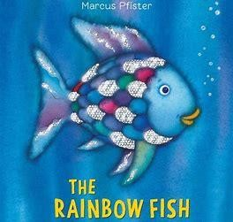 | - Creating their own Rainbow fish/developing descriptive language  - Small group discussions about their own experience of sharing  - Rainbow fish puppets to encourage orally retelling the story  - A range of fish and shells in water trays for children to retell the story and possibly create their own story.  - Cards to sequence the story. | - Creating a thank you card for the rainbow fish  - Mark making in the sand – this could include messages for the Rainbow Fish  - Rainbow mark making with paints ( this can include paining letters learnt in Phonics and/or their names.)
Owl Babies  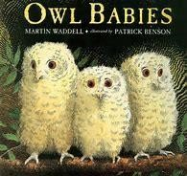 | - Leaves and twigs to create their own nests for baby owls  - Creating pictures of the main characters and describing each of the owls  - Small world scenes with Autumn leaves and twigs and owls which children  - Using a story/treasure box containing three different baby animals to create their own versions of owl babies- this will be modelled by and adult  - Talking about their own families and special people-they could show pictures of these people. | - Messages from Sarah, Percy and Bill  - Labelling their own owl picture  - Creating a list of items that you need to make a cosy nest for an owl  - Creating a simple book/ poster about their own special people
Stickman  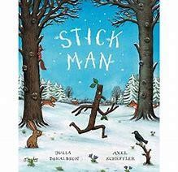 | - Visiting the park and creating their own stickmen  - Creating a class story map and orally retelling the story  - Cards available to sequence the story  - Small world scene set up using leaves and natural materials  - Crreating different items with a stick –then showing these to their friends  - Watching animated version of the Stick man as a stimulus | - Mark making with sticks in the mud and sand  (this can include writing letters or your name)  - Materials to create their own story map/  - Postcards to Year One from Stickman

Autumn Two
Key Focus Text | Suggested Provision for extending vocabulary; orally retelling texts and creating their own narratives | Suggested Writing Provision  At this stage activities will also include opportunities for mark making and drawing
Leaf man  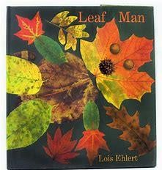 | - Collecting Autumn Leaves in Oakhill Park. They could be asked to describe these leaves.  - Retelling the story orally and with actions  - Creating their own leaf men collages and talking about the leaves they have used  - Thinking of different uses for leaves- e.g a boat, a dress or a necklace | - Creating simple story maps of where leaf man travelled too. They could also think of an alternative journey he had been.  - Recording all the different things that could be created with leaves.  - Creating a group message to the rest of the school about why Autumn leaves are so wonderful
The Gruffalo  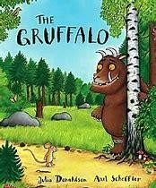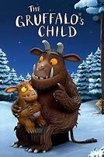 | - Taking children on a walk around the school to look for the Gruffalo  - Creating their own pictures of the Gruffalo  - Sequencing pictures from the story  - Orally retelling the story as a whole class using actions.  - Creating their own versions of the Gruffalo story. This could be done by using simple props to change the characters that the Gruffalo encounters – it will need to be modelled.  - Role play area could be set up as a Gruffalo cave. Discuss what the Gruffalo would have in such a place. | - Making signs to warn people about a Gruffalo being on the School grounds.  - Creating pictures and labels for a Gruffalo den Role Play Area  - Mark making in soil in sand. Creating warning signs for other creatures about the Gruffalo  - Writing a message from the Gruffalo’s child to the Gruffalo  - Using natural materials to create marks and write messages in the out door area
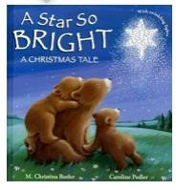  A starry night | - Role play area to be set up as a nativity scene  - Crib to be set up in the classroom (Adult led activities will include using these figures to talk about the story  - Puppet theatre to be set up with figures from the Christmas story  - Taking on the role of different animals in the story and thinking about what they would say and where they would want to stand when they are in the stable.  - Creating their own starry night scenes | - Writing Birthday cards for Jesus  - Using glitter and glue to mark make and practise letter formation on dark paper ( this could be linked to making their own starry night sky)  - Children who are ready could create their own story maps of key events in the story.
Spring One
Key Focus Texts | Suggested Provision for extending vocabulary; orally retelling texts and creating their own narratives | Suggested Writing Provision  At this stage activities will also include opportunities for mark making and drawing
Goldilocks and the Three  Bears  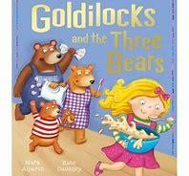 | - Role play area to be set up as three bears house so children can act out the story  - Children to pretend that they are investigating who broke into the three bears house  - Props in the indoor and outdoor areas so that children can retell the story  - Cards for sequencing the story  - Create a crime scene the role play area and make up stories about what could have happened  - Following instructions for making porridge. Describing how the porridge changes | - Signs to warn Goldilocks to keep out  - Tracing and mark making in the porridge oats  - Clipboards to write / draw pictures of • Creating their own story maps  - Provision for creating sorry cards.
Whatever Next  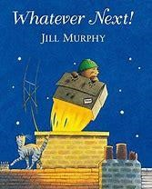 | - Role play area to be set up with items for the story and a picnic set • destination they were flying too.  - Plan the own journey to the  - Read further texts about space  - Pretend to go on a journey to space. Children could create a giant space picture of what they can see in Space  - Story box activity to encourage the children to create their own versions of the story. They could change the character the meet on the way or by | - Making a list of items they want to take on a visit for the moon  - Creating a postcard from the moon  - Resources available in the free writing areas that encourage writing about Space  - Practising writing letters in space (using chalk to write on dark paper
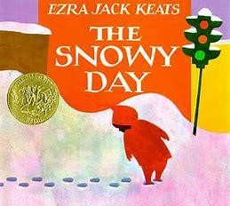  A Snowy Day | - Creating their own snow scene pictures  - Small world props set up in fake snow or • Fake snow for children to explore and describe.  - Creating their own snow paintings.  - Imagining what they would do on a snowy day  - Ice set up in the active world tray so that children can describe and experience the temperature of snow. | - Painting snow letters (with white paint on dark paper)  - Creating their own zig zag books about things that they would do on a snowy day. They could share these with a buddy,  - Some children could create their own story maps showing what happens in the story

Spring Two
Text | Suggested Provision for extending vocabulary; orally retelling texts and creating their own narratives | Suggested Writing Provision  At this stage activities will also include opportunities for mark making and drawing
Jack and the Beanstalk  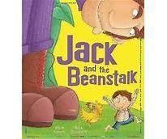 | - Creating models of what would be at the top of their beanstalk and talking about them with friends.  - Small world toys set up so that children can create their own story  - Story box activity in groups. The children will make up their own story in which they changing what they find at the top of the story (this will be modelled by an adult  - Creating dishes in the role play area for the Giant.  - Puppets so that children can retell the story | - Creating labels for their plants  - Thinking about what could be at the top of a beanstalk and creating a class book for the Reception library.
My Bean Diary  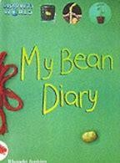 | - Follow instructions to plant their own beanstalks  - Using play dough to create and describe their own bean stalks  - Gardening equipment, pots, small seed sized items and earth will be set up in the outdoor area so that children can pretend to plant new flowers.  - Cards to sequence the growth of a new plant. | - Writing guidance for members of staff to explain how to plant a bean stalk  - Writing guidance on how to look after a bean stalk e.g. “Water your bean every day”  - Mark making with mud
The Extraordinary Gardener  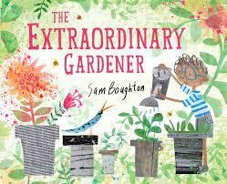 | - Looking for the most extraordinary plants in Oakhill Park  - creating their own garden boxes in small groups  - (with construction toys or paints)  - Painting different flowers such as daffodils –describing  - Using natural items collected from school ground Park to create potions and garden pictures in the outdoor area • Planting different flowers | - Creating a picture of an extraordinary garden. Write simple sentences to label and describe this garden.  - Writing a message / letter to Mr Waller asking him to help them create their own gardens.  •

Summer Two
Text | Suggested Provision for extending vocabulary; orally retelling texts and creating their own narratives | Suggested Writing Provision  At this stage activities will also include opportunities for mark making and drawing
Hungry Caterpillar  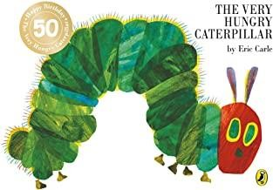 | - Observing caterpillars as they change into butterflies. They could record updates for the school website  - Painting pictures of butterflies and describing what they look like • Props and puppets to be set out for children to retell the story.  - Children to be encouraged to role play their own versions of the story- perhaps changing the food that the caterpillar could eat. | - Writing observations about the class caterpillars. These could then go out the website  - Writing their own versions of the Hungry Caterpillar- this could be carried out as a group or as a class.  - Posters reminding other children to be careful near the caterpillars
The Snail Trail  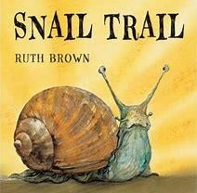 | - Painting a story wall  - Roleplaying the journey that the snail has gone on.  - Describing a different journey that a snail could go on- creating different landscapes for him to travel along.  - Hot seating the snail about how he felt during his journey. | - Creating captions showing how the snail feels at different points in the story. These could be attached to the story wall  - Creating their own snail trail writing by using water in the outdoor area.
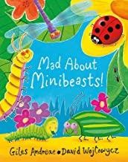  Mad about Minibeasts | Making models with play dough  Looking for mini-beasts in the school grounds. Describing what they have seen  Creating their own playdough minibeasts  Playing “Guess which minibeast I am thinking of” . One child would give a description of a mini beast and the others have to guess which mini beast they are thinking of. | - Keeping a record of the minibeasts they have seen around the school ( This cold include labelling pictures that they have drawn_  - Creating factfiles about mini beasts. These could be to help Year Two witht he

Spring Two
Text | Suggested Provision for extending vocabulary; orally retelling texts and creating their own narratives | Suggested Writing Provision  At this stage activities will also include opportunities for mark making and drawing
Mad about Dinosaurs  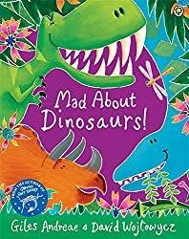 | - Creating pictures of their favourite Dinosaurs.  - Designing their own imaginary dinosaur and deciding what it would be called, what it would look like and what it would eat.  - Create a scene where dinosaur eggs have been found. Creating a news report about their amazing  - Small world dinosaurs to be set up | - Creating a fact file for their own imaginary dinosaur  - Creating signs explaining that they have found dinosaurs.  - Writing messages to tell everyone about the dinosaur eggs that have been found.
Harry and the Bucketful of  Dinosaurs  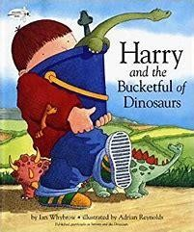 | - Retelling the story by sequencing cards  - Setting up buckets and dinosaurs so that children can role-play certain parts of the story.  - Hot seating Harry  - Roleplaying the conversation between Harry and the person in Lost and Found and Found office  - Small world characters for children retell parts of the story and to create their own new stories. | - Creating poster for Harry asking to look for his missing dinosaurs.  - Writing thank you cards to the people who found his dinosaurs
Emma Janes Aeroplane  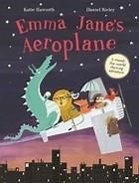 | - Sequencing pictures from the story  - Using props creating their own imaginary aeroplane journey  - Think about places they would want to travel to on an aeroplane  - Role playing conversation between Emma Jane and the animals  - Creating models of places that they would like to visit (could be using old junk or construction toys  - Setting up the role play area as an aeroplane | - Writing a post cards from Emma Jane  - Create a map of journey that they would like to go on  - Writing thank you messages to the animals that rescued the aeroplane

